Website Launch BoX prep page

Understanding Your BRAND
Please select the primary THREE brand associations word you would like your brand to convey?
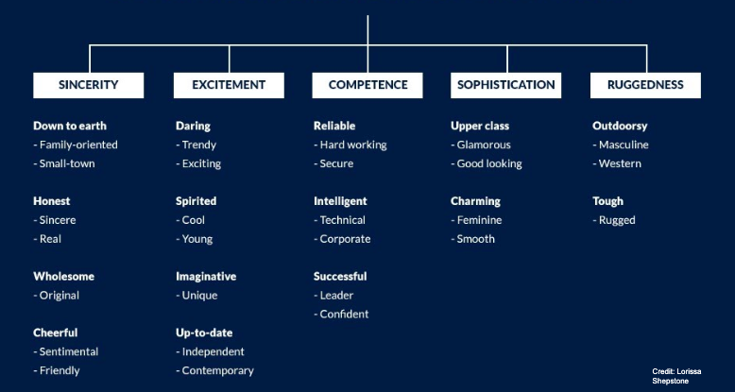
1. Adjective One:
2. Adjective Two:
3. Adjective One:

Please list up to example three websites similar to the website you would like for your company
1.
2.
3.

Brand Colors
If you have any current brand colors, please provide the HEX or RGB codes for them. If not, tell me a little bit more about the types of colors you would like in your website.

General Rules of Thumb about Colors
- Cool colors evoke feelings of trust, loyalty and stability
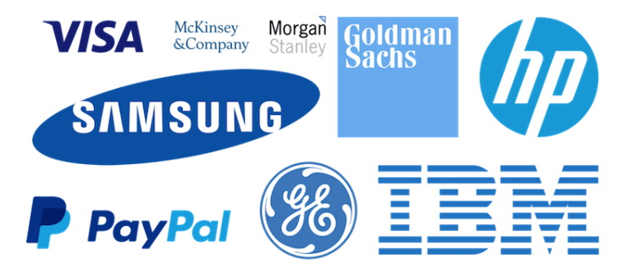
- Warm Colors energy, excitement, and positivity

Understanding Your Users
Use this document to help design what features your website needs

Please describe the three major types of people who might interact with your website in as much detail as possible | Please list the three major actions they should do on your website (ie. sign up for your newsletter, review your past work, locate your contact information etc etc)
Primary User 1
Primary User 2
Primary User 3

Navigation
If you are able to, write out how you would like the navigation/menu to be displayed with any subpages needed.

Ex. Primary Page
- Subpage

COPY
If you are able to, please include any copy you have for your website. Don’t worry if it still needs to be workshopped/edited, there is time to do so later

Page | Copy/Content

Prep Images
If you have them, please gather any images and/or logos you would like to for your website to send over.

Other Information
Is there anything else you would like me to know before beginning your website?

